Project Plan

Secure Password Manager

CS467/Spring/2026

Johnathan Harrison, Humza Hussain, Eric Mitchell, Joshua Kim

Change Log
Who did what and when. Helps to have an audit trail IRL. The table can grow as needed.
Change | Author | Date
Problem Statement | Eric | 4/9/2026
Technologies | Humza | 4/9/2026
Requirements | Eric | 4/10/2026
Dev Plan - Johnathan | Johnathan | 4/10/2026
Design/Arch Figma Diagram | Johnathan | 4/10/2026
Dev Plan - Eric | Eric | 4/12/2026
Design / Architecture | Eric | 4/12/2026
Dev Plan - Humza | Humza | 4/12/2026
Introduction | Johnathan | 4/12/2026
Expand & restructure Architecture section | Johnathan | 4/12/2026
Important Resources &  add citations | Johnathan | 4/12/2026
Conclusion meme | Johnathan | 4/12/2026
Dev Plan - Joshua | Joshua | 4/12/2026

Introduction
This Secure Password Manager project is a web application designed to help users store and manage website credentials in a safe and organized way. It gives users a centralized and secure system not only for storage but also generating strong passwords and ensuring only authorized access through multi-factor authentication.

What makes this project special is its focus on demonstrating high usability and security in a relatively light-weight and fully open-source web application. The app is intended to ultimately guide users toward better security practices through its MFA and strong password generation features. The project is also structured as a full-stack team effort with distinct frontend, backend, deployment and database responsibilities. Our team aims to build a real software system using modern tools and platforms on a restricted timeline.

Problem Statement
In today’s digital world, the need for secure password management solutions is growing. Strong passwords play a crucial role in protecting online security [1][2]. It is also common practice in many organizations for users to update their passwords periodically and prohibit the reuse of previous passwords. This forces users to frequently create new, strong passwords as well as remember their new passwords to avoid requesting even more frequent resets.
Despite these requirements, users frequently struggle to create and maintain strong, unique passwords for multiple accounts. This leads to unsafe practices, such as choosing weak passwords, reusing passwords, or storing passwords in unsecured locations like sticky notes or note applications. These behaviors increase the risk of password breaches and unauthorized access.
This problem affects internet users, students, and professionals who use multiple online services and lack tools to manage their credentials safely. This problem is becoming increasingly relevant in an era where data breaches are becoming more common [3]. Without a secure and reliable application to store and generate passwords, users are more likely to be the victim of a cyberattack. Victims of the attacks often experience financial loss, privacy violations, and the burden of resecuring their accounts [4].
To address this issue, a user-friendly and secure password manager web application can be developed. This application will allow users to store their credentials in a secure and encrypted manner, help generate strong passwords, and access their information through a multi-factor authentication. This application aims to simplify password management while enhancing a user’s security.

Requirements
The goal of this project is to create a user-friendly and secure password manager web application. The password manager will have features that enhance user security, such as multi-factor authentication when a user logs in. Additionally, to promote the creation and usage of strong, unique passwords, the application will include a password suggestion feature that generates passwords based on user input. These features, combined with encryption and secure cloud hosting will create a secure solution to managing credentials. A full list of project features can be found below:
- User Registration and Authentication
- Multi-factor authentication when a user logs in with master password
- Password suggestion feature that generates strong passwords based on user input
- Encryption mechanisms
- Secure hosting in the cloud
- Documentation and user guides
- Fully open-source code available via GitHub

Design / Architecture
The system is divided into three main functional areas: the frontend, the backend, and the database layer. At a high level, the user will interact with a React.js frontend hosted on Vercel. The frontend will send secure HTTPS requests to a FastAPI backend hosted on Railway. All secrets like DB credentials, signing keys and MFA data will be securely stored on the backend/database, inaccessible to the client-exposed frontend. The FastAPI backend will contain all application logic, handle authentication and vault operations, and communicate with a PostgreSQL database hosted through Supabase. Finally, GitHub serves as the team’s central development platform for source control, collaboration, and automated deployment.

Figure 1 below shows a high-level architecture for the application. We are still in the planning phase and some of the technologies listed above may be changed.
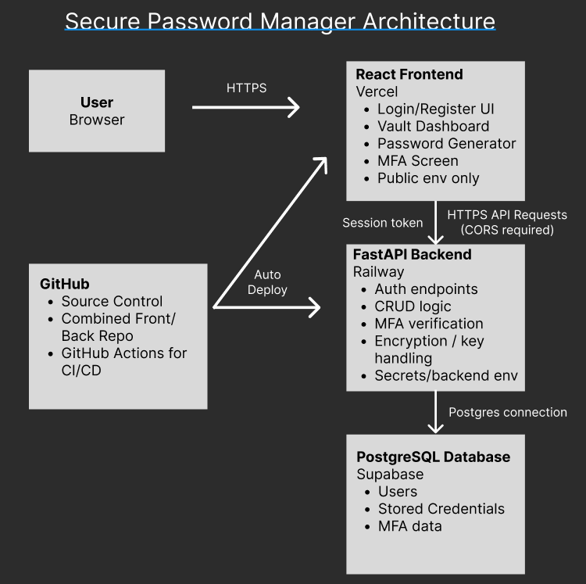

The react frontend will provide the responsive and easy-to-use interface for users to interact with the password manager application. The login and register UIs will handle user registration/authentication and prompt for multi-factor authorization when a user logs in. The frontend will also be responsible for hosting documentation available to explain how to use the application, as well as the dashboard to view a user’s credentials. Password suggestions based on user input will also be handled on the frontend. Since the frontend is hosted separately, it will communicate with the API using HTTPS requests and will only store public configuration values such as the API base URL.
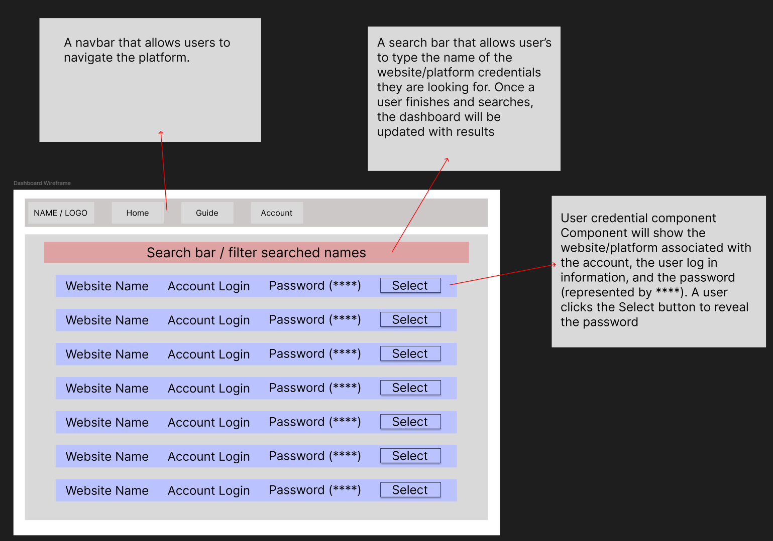

Figure 2 above is a wireframe design for a possible UI for the dashboard page of the application. Users will navigate between web pages using the nav bar at the top, search for specific credentials using the search bar, and have a list of all credentials saved as a default view. Once a user finds the credentials they’re looking for, they can click the Select button, revealing the password for them to use.

The FastAPI backend will handle all CRUD operations (user login/registration, adding/updating/removing credentials from the password vault). It will also handle encryption validation and multi-factor authentication logic. By keeping this logic server-side, the project will minimize the amount of sensitive data processing that occurs in the client. This supports the requirements involving secure authentication, encryption mechanisms, and reliable credential storage.

The database layer will store user account records, stored credential records, and MFA-related data used by the authentication flow. The database schema is still being decided but will store at a minimum the aforementioned data and will structure the data so that users can only access their own stored vault information through the backend.

Finally the deployment and integration layer will connect the whole system into a usable product. Vercel will host the frontend, Railway will host the FastAPI backend, and Supabase will host the PostgreSQL database. GitHub will be used for source control, pull requests, and connecting the deployment workflows. This structure allows each team member to work in parallel on building a single integrated application.

Technologies
- Languages & Frameworks:
  - Frontend: Javascript, HTML, CSS, React.js, Vite, maybe React Router
  - Backend: Python, FastAPI/Pydantic, SQL
- Database: Supabase (PostgreSQL with Row-Level Security)
- Security: Python cryptography library (AES-256-GCM vault encryption), MFA and session token tools/libraries TBD
- Dev Tools & Deployments: Git/GitHub (version control), GitHub Actions (CI/testing), python-dotenv (secrets management), Vercel, Railway, Supabase
- Testing: Pytest (backend unit testing), Vitest (frontend unit testing), Postman (API testing), Swagger UI (FastAPI)
FastAPI was selected as the backend framework for this project due to its native Python support, automatic OpenAPI/Swagger documentation, and strong integration with Pydantic for request and response validation. Compared to heavier alternatives like Django or Spring Boot, FastAPI has a shorter learning curve while still providing production-grade performance.

Important Resources (if any)
- Platform/library documentation
  - React documentation [5]
  - Vite documentation [6]
  - FastAPI documentation [7]
  - Supabase documentation [8]
  - Railway documentation [9]
  - Vercel documentation [10]
  - GitHub Actions documentation [11]
- Figma for wireframes, diagrams, graphics [12]

Development Plan
Team Member | Milestone | High-level Requirement / Story / Feature / Task | Time (hrs) | Major Dependencies / Resources / Risks
Johnathan Harrison | Progress Report #1 | Set up the React frontend project and get the basic file structure ready for pages, components, and styling. | 5-8 | Need repo access and agreement on what frontend tools we are using.
 |  | Spend time learning any new front-end technologies needed for the project. | 8-10
 |  | Make the basic page layouts and navigation for login, registration, vault, and add/edit credential pages. | 5-8 | Requires team agreeing on the main screens and general user flow.
Johnathan Harrison | Progress Report #2 | Build the registration and login pages | 7-8
 |  | Build the main vault page to show saved credentials in a way that is easy to read and use. | 7-8 | Depends on knowing what the credential data will look like.
 |  | Build forms for adding, editing, and deleting saved credentials. | 8 | Depends on backend routes and final decisions on what fields each entry should have.
 |  | Build the password generator part of the UI and connect it to either frontend or backend logic. | 6 | Depends on whether password generation is handled on the client or server side.
Johnathan Harrison | Progress Report #3 | Build the MFA screens and flow, including entering a code and showing success or error messages. | 8 | Depends on how MFA is implemented by the backend teammate.
 |  | Improve the frontend experience with responsive layout fixes and small quality-of-life features like show/hide password and copy password. | 8 | May change based on feedback from teammates or the project mentor.
 |  | Test the frontend with the rest of the system and fix bugs found during integration. | 4-8 | Could take longer if backend changes happen late.
Johnathan Harrison | Project Archive - Final | Finish final frontend integration, clean up code, and fix any remaining bugs. | 8 | Depends on final backend stability and deployment progress.
 |  | Write frontend documentation and help make user guide material with screenshots of the finished pages. | 8 | Fully possible only once the UI is (mostly) finalized.
 |  | Help get the frontend ready for the final demo and make sure the main user flow works smoothly. | 6 | Depends on the full app being stable enough for presentation.
Johnathan Total Hours: ~90
Team Member | Milestone | High-level Requirement / Story / Feature / Task | Time (hrs) | Major Dependencies / Resources / Risks
Eric Mitchell | Progress Report #1 | Set up project file structure / dev environment | 4
 |  | Create a low-fidelity wireflows to show user flow | 4
 |  | Familiarize with React fundamentals and React hooks | 6-10
 |  | Iterate over wireflows for feedback and create prototype | 4
Eric Mitchell | Progress Report #2 | Research UI libraries | 5
 |  | Reiterate over prototype and gain feedback on usability | 6
 |  | Build reusable UI pieces like buttons, form fields, cards, and password input components. | 6 | Depends on if design changes
 |  | Connect backend endpoints to frontend | 4-6 | Depends on challenges setting up middleware
Eric Mitchell | Progress Report #3 | Add form validation, loading states, and error messages across the main pages. | 6
 |  | Research cloud technologies to deploy application to | 5
 |  | Set up cloud technology deployment pipeline | 4-6
 |  | Work on fixing UI errors, rendering issues, bugs | 6-8
Eric Mitchell | Project Archive - Final | Help with frontend deployment setup, production build testing, and fixing browser-side issues after deployment. | 6
 |  | Assist with documentation/user guide | 4-6
 |  | Make sure deployment on both front end and back end are working, help debug if any issues | 4
Eric Total Hours: ~80
Team Member | Milestone | High-level Requirement / Story / Feature / Task | Time (hrs) | Major Dependencies / Resources / Risks
Humza Hussain | Progress Report #1 | Set up FastAPI project structure, install dependencies, and configure environment variables | 4-6 | Requires team agreement on final stack
 |  | Learn FastAPI fundamentals, routing, and Pydantic model patterns | 6-8
 |  | Implement user registration and login endpoints with bcrypt password hashing and JWT token issuance | 4-6 | Schema must be finalized
Humza Hussain | Progress Report #2 | Implement multi-factor authentication endpoints | 8-10
 |  | Build vault CRUD endpoints (create, read, update, delete credentials) | 8-10
 |  | Add JWT authentication middleware to protect all vault and user routes | 4-6
Humza Hussain | Progress Report #3 | Build password generation endpoint with configurable rules (length, symbols, numbers) | 3-4 | Frontend password generator UI depends on this
 |  | Write Pytest unit tests for auth, encryption, and vault endpoints | 6-8 | Depends on all endpoints being mostly stable
 |  | Deploy FastAPI backend to Railway and configure environment variables and Supabase connection | 4-6 | Requires Railway account setup and Supabase credentials
 |  | Test all API endpoints end-to-end with frontend and db integration, fix any issues | 4-6 | Depends on frontend and db being connected
Humza Hussain | Project Archive - Final | Fix bugs found during final integration and testing | 4-6
 |  | Write backend API documentation and contribute to user guide | 4-6
 |  | Final deployment verification and demo prep | 4
Humza Total Hours: ~85
Team Member | Milestone | High-level Requirement / Story / Feature / Task | Time (hrs) | Major Dependencies / Resources / Risks
Joshua Kim | Progress Report #1 | Research Supabase architecture and MySQL to PostgreSQL translation | 4-6 | Dependencies:  Supabase and PostgreSQL documentation
 |  | Research/explore Supabase integration with Railway | 4-6 | Risks: integration/configuration issues, environment variables, connection failures
 |  | Set up Supabase project instance with best practices concerning authentication/MFA systems | 4-6 | Dependencies:  Supabase documentation and authentication guidelines. Backend requirements.
Joshua Kim | Progress Report #2 | Design database schema for users, authentication credentials, and MFA | 8 | Depends on Backend requirements and app features
 |  | Define relationships (tables/keys) | 2-4 | Resources:  Supabase/PostgreSQL documentation
 |  | Normalize data structure | 2-4
Joshua Kim | Progress Report #3 | Integrate Supabase w/ Backend | 4-6 | Dependencies/resources:  Supabase API/SDK documentation, backend architecture and railway environment.
 |  | Implement CRUD operations for user data | 6-10
 |  | Test database queries and responses and ensure proper error handling. | 5-8 | Supabase testing tools, API endpoints, logging/monitoring utilities.
Joshua Kim | Project Archive - Final | Configure Supabase Auth | 4-6
 |  | Implement password hashing and secure storage, add MFA support | 6-10 | Supabase documentation, backend architecture and railway environment. MFA implementation guides
 |  | Validate authentication flows and conduct security checks. | 5-8 | Supabase API/SDK documentation, backend architecture and railway environment.
Joshua Total Hours: 80

Conclusion
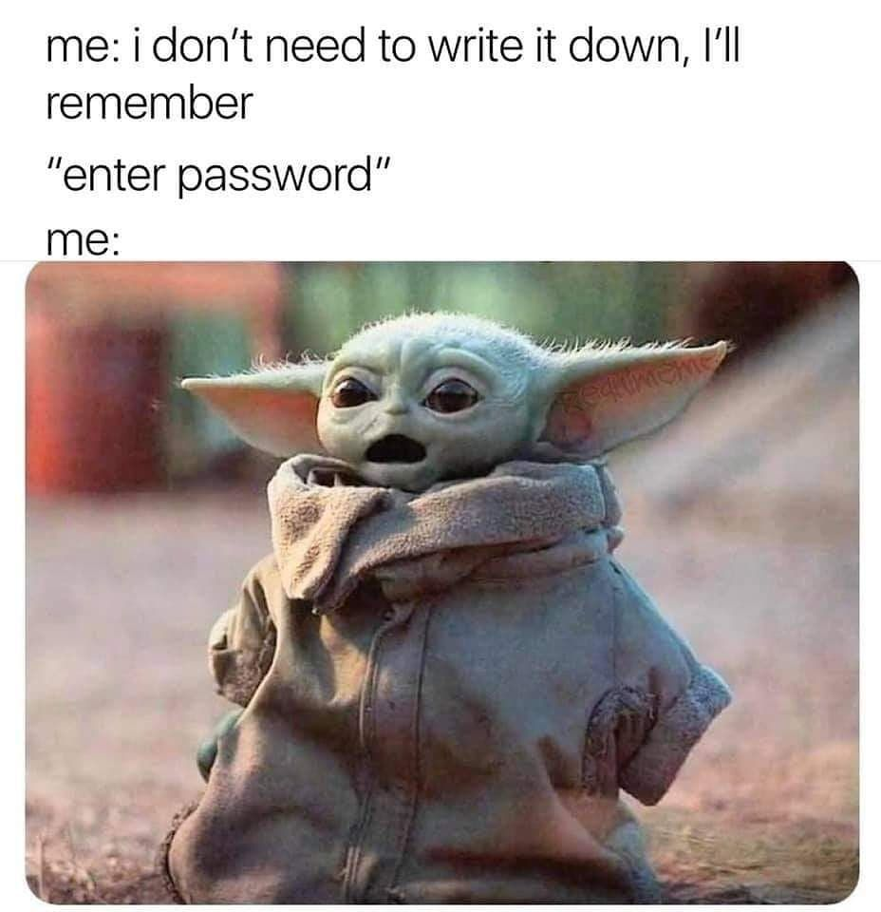
Figure 3. Baby Yoda Meme [13]

References
If needed. Please use the following style:
This is the body of your paper here. Text text text, blah blah blah [1]. Some more text.
(and below in References)
[1] The reference. APA or IEEE style.
- National Institute of Standards and Technology. (2025, August 26). SP 800-63B: Authentication and authenticator management. https://pages.nist.gov/800-63-4/sp800-63b.html
- Cybersecurity and Infrastructure Security Agency. (n.d.). Secure yourself & your family. https://www.cisa.gov/secure-our-world/secure-yourself-your-family
- Verizon Business. (2025). 2025 Data Breach Investigations Report. https://www.verizon.com/business/resources/reports/dbir/
- Verizon Business. (2025). 2025 Data Breach Investigations Report. https://www.verizon.com/business/resources/reports/dbir/
- React Documentation
- Vite Documentation
- FastAPI Documentation
- Supabase Documentation
- Railway Documentation
- Vercel Documentation
- GitHub Actions Documentation
- Figma
- Source: JH Specialty. (2020, July 22). Types of password managers for safe organization. https://www.jhspecialty.com/blog/password-managers

